SOA EXPERIMENT – 3
Experiment 3: Development of User Registration Service using Spring Boot and PostgreSQL

PORJECT STRUCTURE:-

SOA_user-registration
│
├── src/main/java
│ └── com.example.demo
│ ├── config
│ │ └── SecurityConfig.java
│ ├── controller
│ │ └── UserController.java
│ ├── dto
│ │ ├── LoginRequest.java
│ │ └── RegisterRequest.java
│ ├── entity
│ │ └── User.java
│ ├── exception
│ │ └── GlobalExceptionHandler.java
│ ├── repository
│ │ └── UserRepository.java
│ └── service
│ └── UserService.java
│
├── src/main/resources
│ └── application.properties
│
└── pom.xml
STEP -1 CREATE A POSTGRESQL DATABASE
->open pg admin
->connect to postgresql
->create user_registration
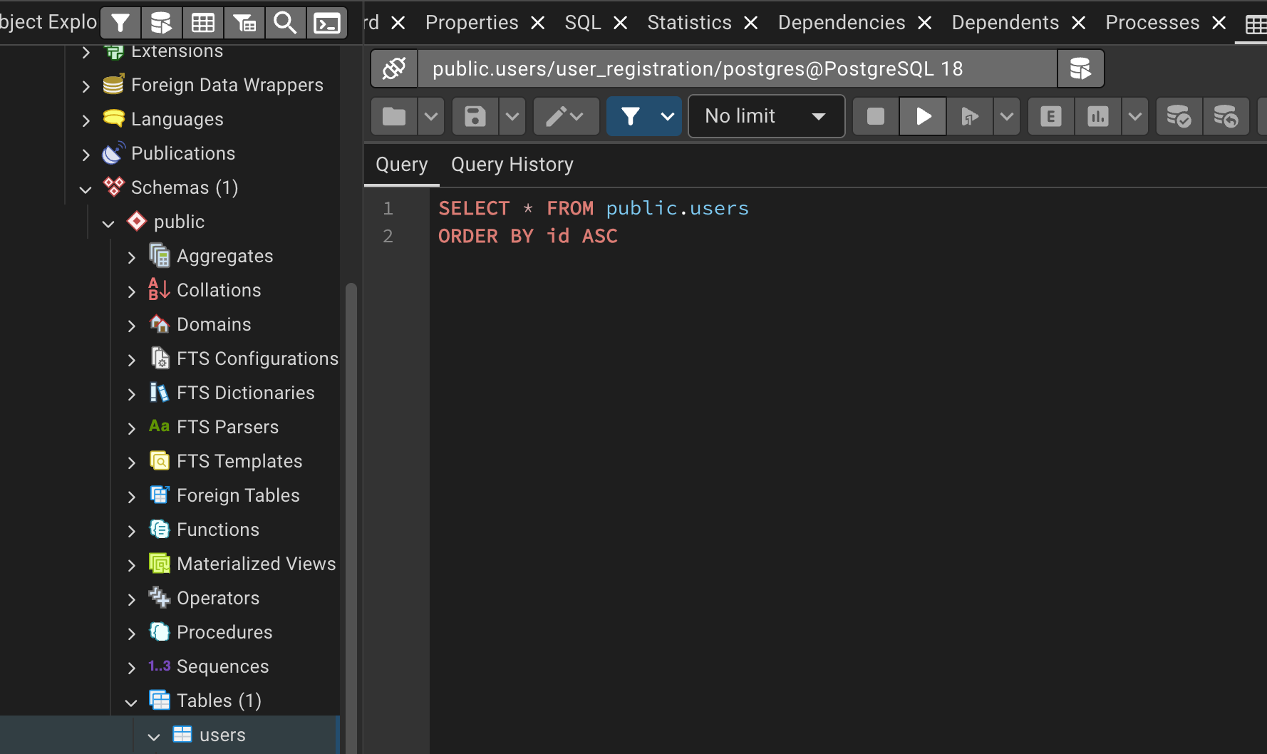

STEP-2: CONFIGURE DATABASE CONNECTION
-> Open src/main/resources/application.properties in the eclipse
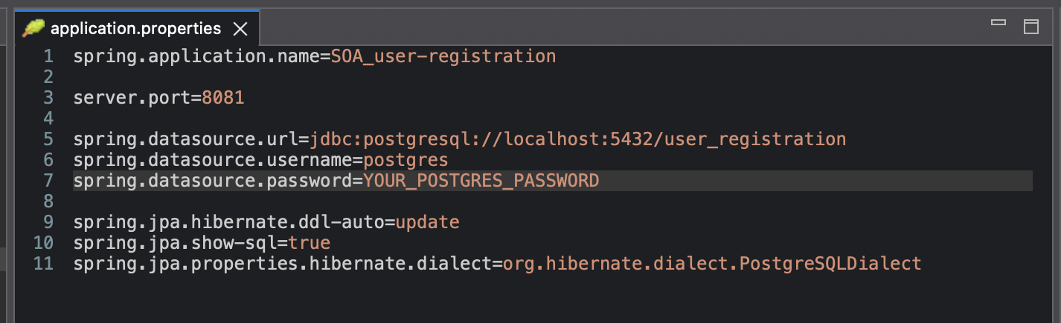

STEP-3:- CREATE USER ENTITY
->RegisterRequest.java
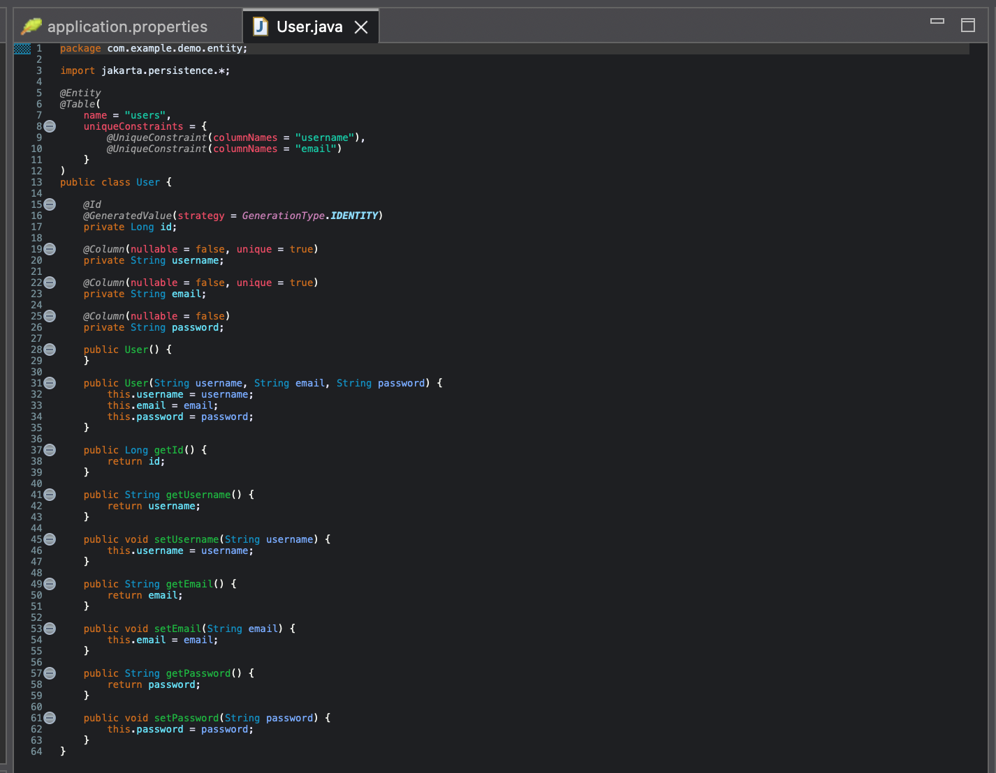
STEP-4:- CREATE REGISTRATION DTO
->open RegisterRequest.java
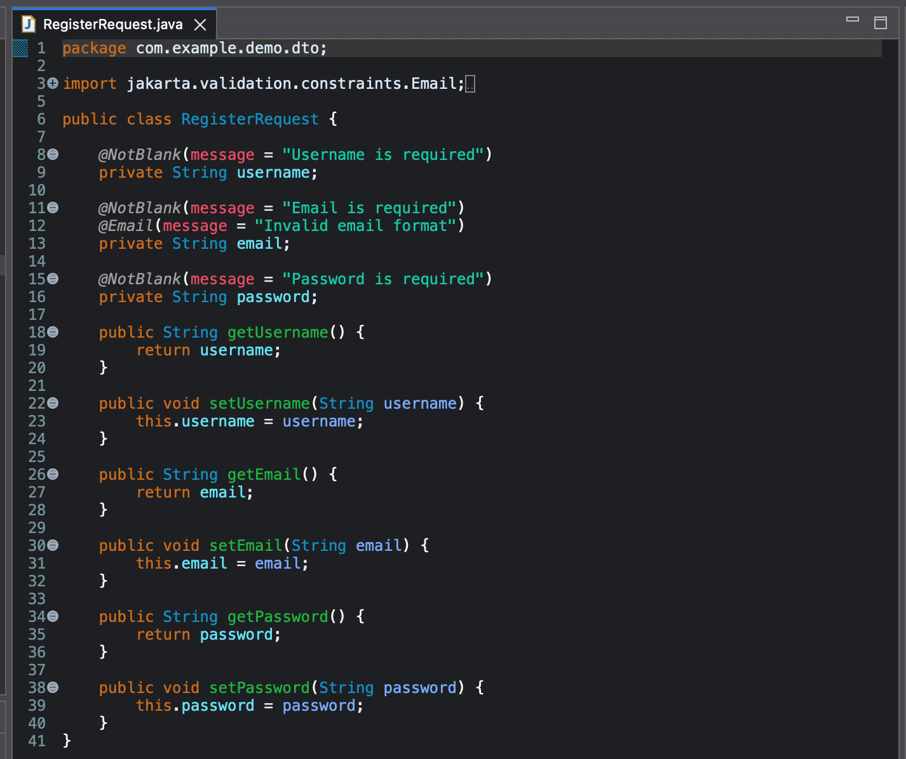
STEP-6:- CREATE REPOSITORY LAYER
->open UserRepository.java
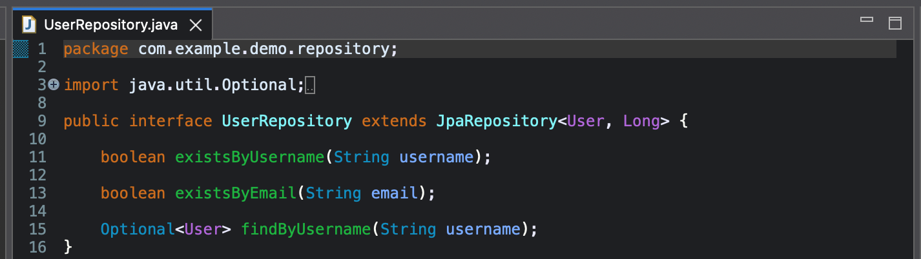
STEP-7:- CREATE SERVICE LAYER
-> open UserService.java
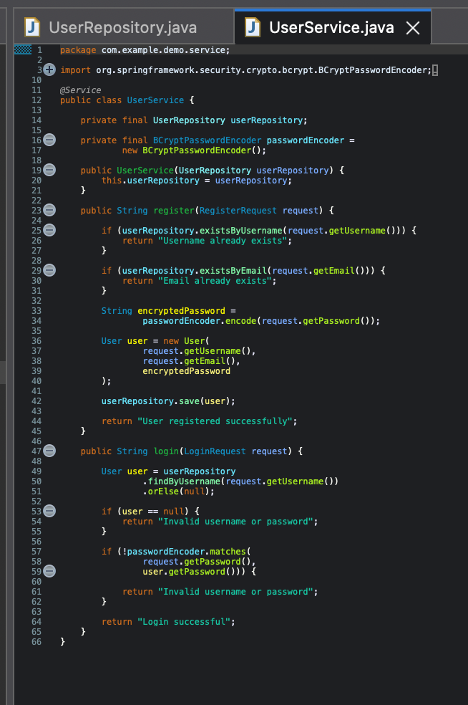

STEP-8:- CREATE CONTROLLER LAYER
->open UserController.java
->The Controller layer exposes REST API endpoints for user registration. It receives HTTP

requests from the client and passes the data to the Service layer.
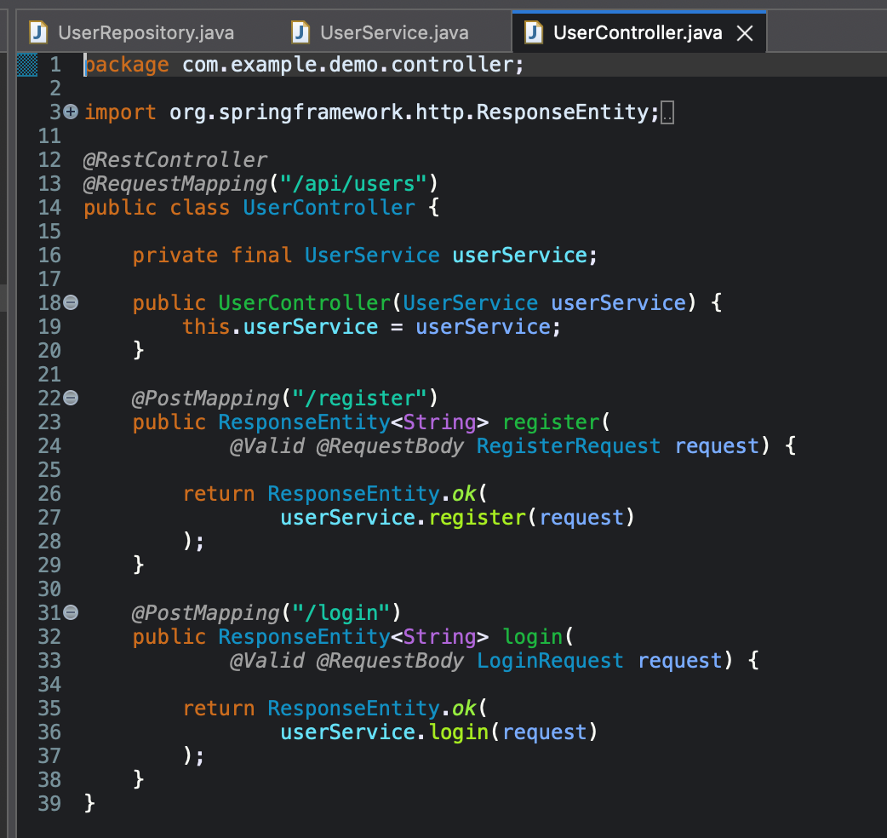

STEP-9:- CREATE EXCEPTION HANDLING
->open GlobalExceptionHandler.java
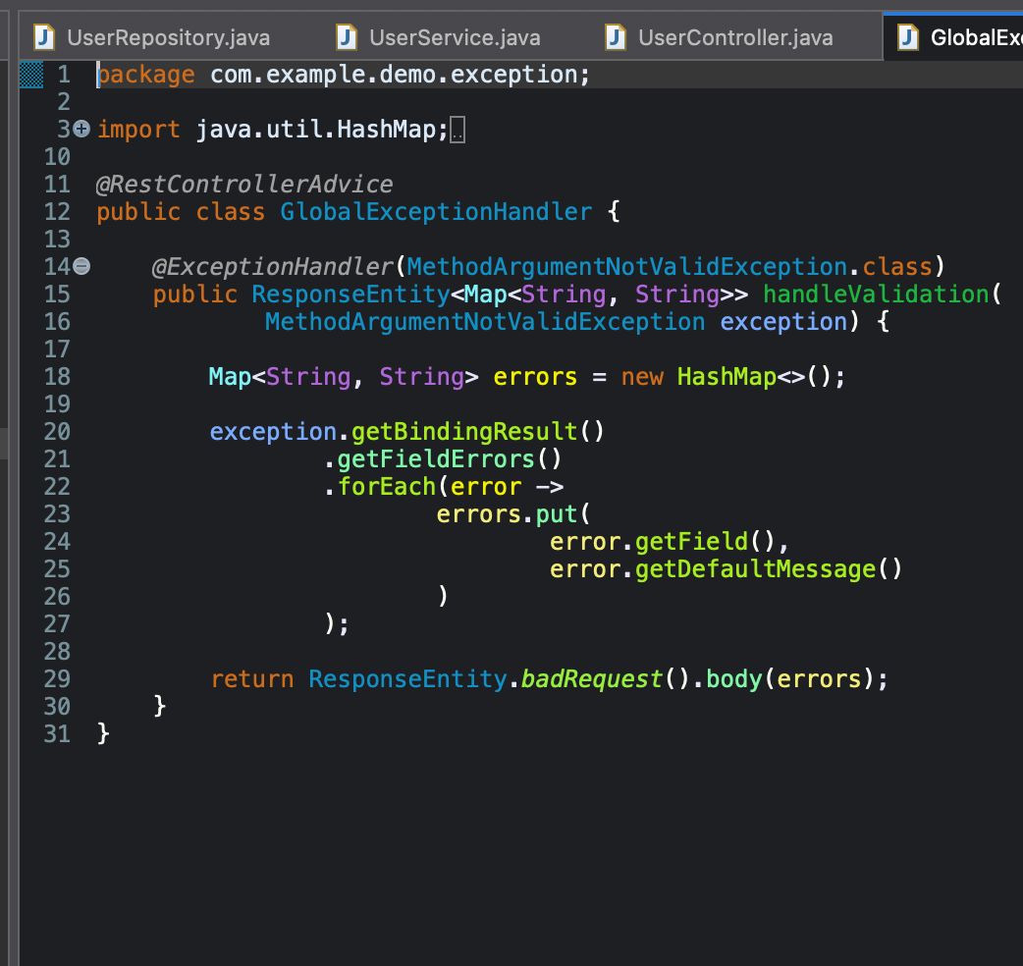

STEP-10:- SECURITY CONFIGURATION
->OEPN SecurityConfig.java
->Security configuration is used to define the security behavior of the Spring Boot application, including authentication and authorization rules for API endpoints
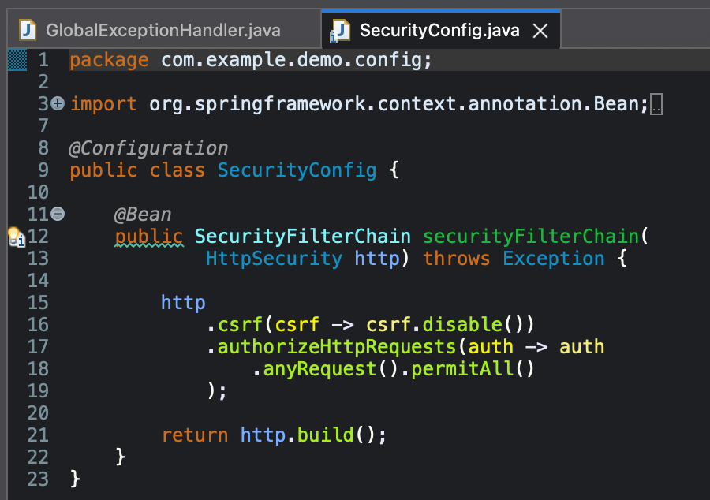

STEP-11:- RUN THE APPLICATION
-> OPEN SoaUserRegistrationApplication.java
-> Right-click → Run As → Spring Boot App
-> check the console :-
Tomcat started on port 8081 .
Started SoaUserRegistrationApplication
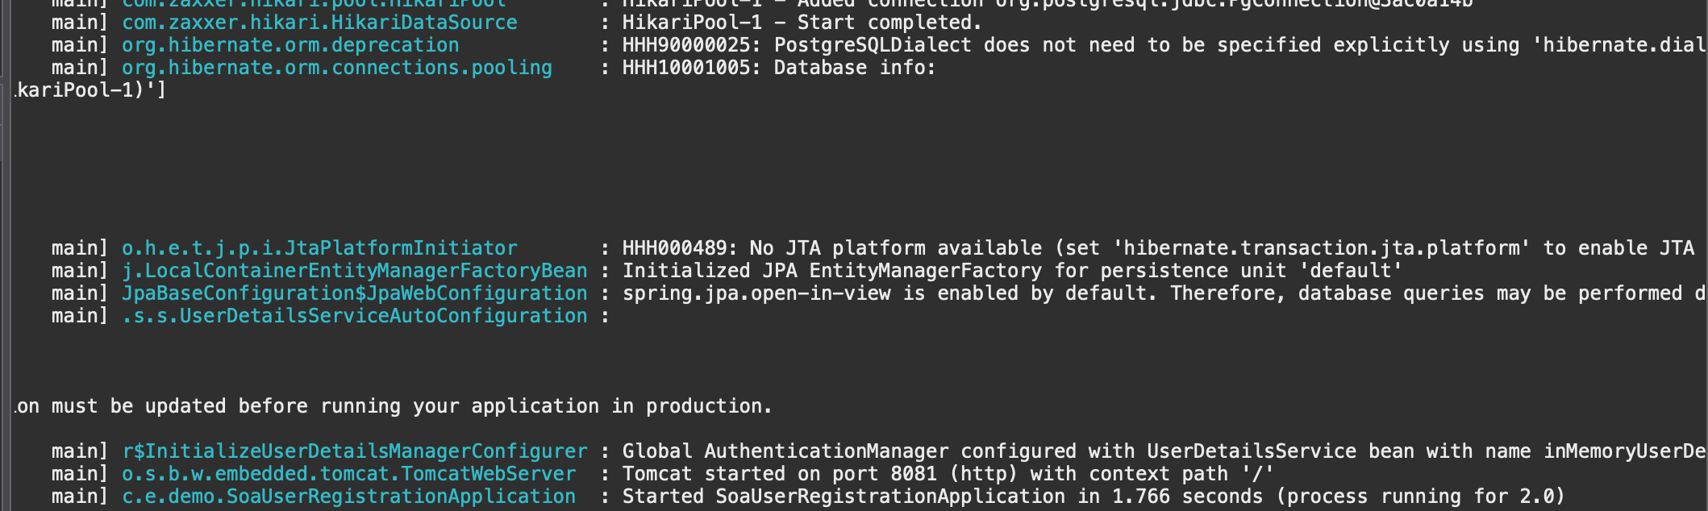

STEP-12:- TEST THE API
-> open POSTMAN

->POST, URL:- http://localhost:8081/users/register
->then select:-
Body
→ raw
→ JSON

-> SAMPLE CODE INPUT:-
{
"username": "vaishu",
"email": "vaishu@gmail.com",
"password": "123456"
}
-> OUTPUT:-
